1) GENERATED IMAGE: 

REFERENCE IMAGE:
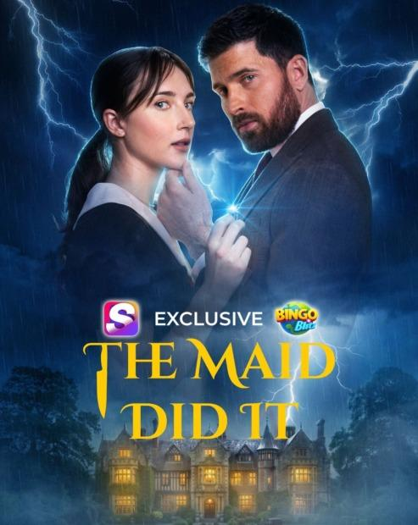

PROMPT:
Editorial gaming news article header banner, 3:2 horizontal. Designed like a TechCrunch / The Verge / Sifted feature article header about a Snapchat × Bingo Blitz interactive movie partnership. Layout: on the LEFT, a tightly cropped cinematic thriller image — a young woman in maid's uniform and a man in a dark suit, dramatic stormy mansion atmosphere with subtle lightning (preserved style from reference image, recomposed). On the RIGHT, clean editorial typography on a soft off-white panel: a small red kicker 'EXCLUSIVE PARTNERSHIP', a bold dark-navy headline 'SNAPCHAT LAUNCHES INTERACTIVE THRILLER WITH BINGO BLITZ', a one-line subhead 'The Maid Did It marks first co-produced mobile-gaming film experience'. Include small clean Snapchat ghost icon and Bingo Blitz logomark side-by-side near the headline. Professional designer-made magazine spread aesthetic, not AI-cinematic. 3:2 banner.

2) GENERATED IMAGE:
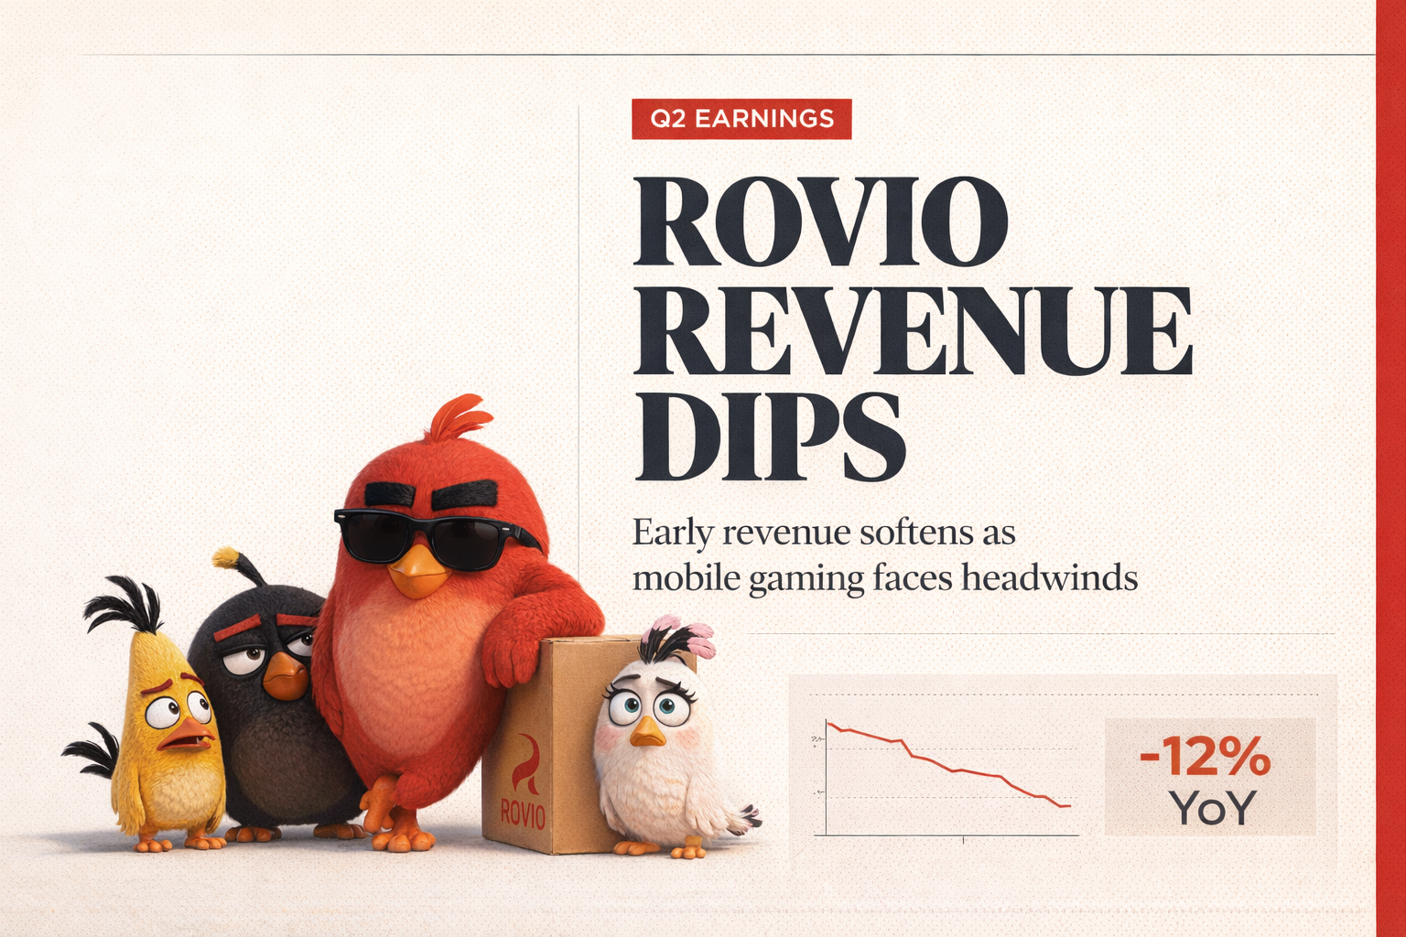

REFERENCE IMAGE:


PROMPT:
Premium editorial magazine-style news cover for a gaming business article, designed like a Bloomberg Businessweek / The Information / Sifted feature header — visually rich but designer-restrained, NOT AI-cinematic. CRITICAL: preserve the Angry Birds characters from the reference image — Red (large red bird with sunglasses), Bomb (black bird), Chuck (yellow bird) and Stella (white bird) — kept faithful to the reference, do not redraw or restyle them. Layout: characters grouped on the LEFT third of the composition standing on a flat surface. RIGHT two-thirds is the editorial content area featuring: a large bold uppercase headline 'ROVIO REVENUE DIPS' in dark navy serif or strong sans-serif, a small red kicker label 'Q2 EARNINGS' above the headline, a one-line subheading 'Early revenue softens as mobile gaming faces headwinds', a small clean line-chart graphic showing a downward trend in muted red, and a tasteful data callout box reading '-12% YoY' in a contrasting accent color. Background: warm off-white / soft paper-cream tone with a thin red vertical stripe accent on the far right edge and faint dotted-grid texture for editorial feel. Typography hierarchy clear and confident. Looks like a designer-made magazine spread, not AI-generated. Sharp print-quality rendering. 3:2 banner.

3) GENERATED IMAGE:
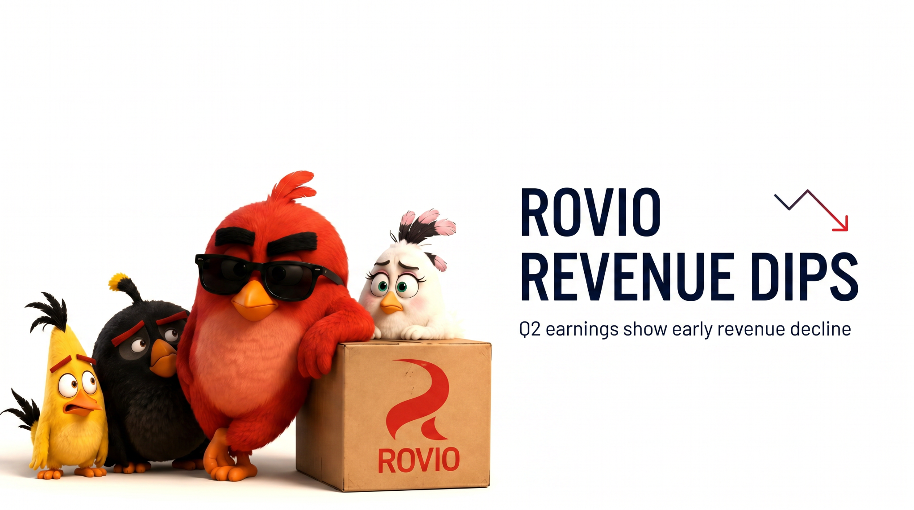
REFERENCE IMAGE:


PROMPT:
Clean editorial business news header graphic on a pure plain white background — minimalist designer style. CRITICAL: preserve the exact Angry Birds characters from the reference image — Red (large red bird with sunglasses), Bomb (black bird), Chuck (yellow bird) and Stella (white bird) — grouped naturally on the left side of the composition, kept faithful to the reference, do not redraw or restyle them. To the right of the characters: clean editorial layout with the headline 'ROVIO REVENUE DIPS' in modern dark-navy sans-serif uppercase typography, with a small subheading 'Q2 earnings show early revenue decline'. Include a thin, minimal downward-trending line chart icon (simple polyline trending down with a small red arrow) as a tasteful design accent near the headline. Background: pure white, perfectly clean, generous whitespace. Press release / Bloomberg / Stripe editorial style. No gradients, no glow, no 3D, no dramatic lighting, no AI-look. Sharp, vector-clean rendering. 16:9 banner.

4) GENERATED IMAGE:

REFERENCE IMAGPROMPT:
Editorial business news header announcing 'SENSOR TOWER ACQUIRES APPMAGIC'. CRITICAL: keep the exact Sensor Tower logo (teal radio-wave icon with 'SensorTower' wordmark) and the exact AppMagic logo (yellow circle with black 'APPMAGIC' text) from the reference image — do not redraw or restyle the logos, place them as-is into a richer composition. Cinematic dark navy gradient background with subtle abstract data-mesh and faint glowing app-icon constellations. The Sensor Tower logo sits on the left over a soft teal glow, the AppMagic yellow circle sits on the right with a warm golden glow, connected by an elegant thin light beam at center. Below them, the headline 'SENSOR TOWER ACQUIRES APPMAGIC' in crisp white modern sans-serif with a thin teal underline accent. Premium TechCrunch / Bloomberg hero-banner feel, soft volumetric lighting, sharp focus, photographic editorial quality, not flat illustration, not AI-looking.

5) GENERATED IMAGE:

REFERENCE IMAGPROMPT:
Premium editorial business news header graphic announcing the acquisition headline 'SENSOR TOWER ACQUIRES APPMAGIC'. Cinematic dark-mode fintech aesthetic: deep midnight-navy gradient background with subtle data-visualization grid and faint glowing app-icon constellations. Two distinct glowing brand orbs floating in 3D space — a luminous teal radio-wave sphere on the left and a bold golden-yellow sphere on the right — connected by a clean light-beam at the center symbolizing the merger. Sleek modern sans-serif typography in pure white, sharp focus, soft volumetric lighting, depth of field, professional Bloomberg-style magazine cover quality. Photographic editorial mood, not flat illustration, not AI-looking. High detail, 16:9 banner composition.

